PARISH CHURCH BULWELL
ST MARY THE VIRGIN & ALL SOULS
THE HILL
BULWELL PARISH MAGAZINE
OCTOBER 2020 Vol. 149 No 10

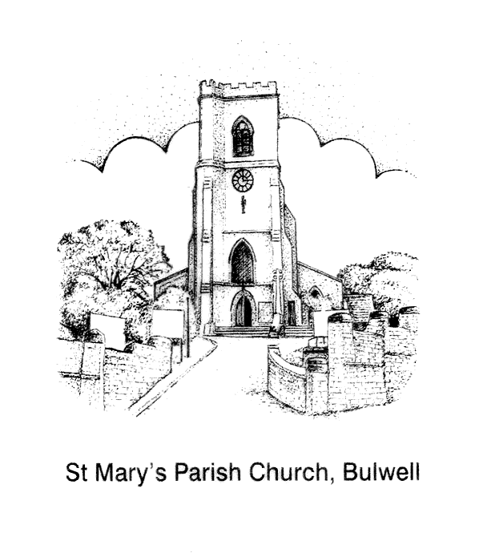

YOUR VICAR WRITES
Dear Reader

It has been good to see our ‘St Mary’s Family’ grow with faces old and new now that we have opened up the building again for worship. It has also been good to see so many folk watching our church services online. If you have come to St Mary’s, either physically to the building or virtually online, I hope you have found the experience uplifting.

Our attending church, our being part of a church family is vital for our spiritual well being. I am reminded of a story I heard many years ago:

There was once a man who had become discouraged from the weight of sorrow and adversity in his life and, gradually, he stopped going to church. He withdrew into himself, and even avoided conversations and visits from concerned friends and family members. He began becoming defensive when anyone suggested he should come back to church, saying that the last thing he needed was people judging him. He began to feel like Job in the Bible, with suffering he felt was undeserved, and rebuffed efforts by his Vicar and members of his congregation to talk about the problems.
One day, his Vicar paid a visit, and because he respected him, the man reluctantly let him in, though warning him he would not be very good company. During the visit, the Vicar said very little, mainly keeping him company, as they sat before the man's fireplace, letting him know he was loved, was being prayed for, and that a lot of people were there for him. The Vicar knew that he had to avoid sounding "preachy," yet wanted the man to realise just how far he was slipping away from God, and the inevitable consequences that could bring. Finally, God spoke to the Vicar, and told him what to do.
As the two men sat in silence before the crackling fire, the Vicar slowly reached out, and picked up the tongs next to the fireplace. He reached into the embers, and took out a single glowing coal, setting it on the stone floor. Puzzled, but remaining silent, the man sat staring at the coal. Gradually, the coal began to lose its colour, finally growing dark and cold until it died. The effect was not lost on the man, and he looked up at the Vicar with tear-filled eyes, realizing he was that coal. He was back in church the very next Sunday.
Without a single word being said, God had communicated a deep spiritual truth that touched the man to his very soul, and brought him out of his spiritual alienation. Sometimes Go d does some amazing things, knowing exactly what we need -exactly when we need it. Sometimes the Holy Spirit of God works through words, and sometimes He works through our spirit.

What is God saying to you today?

“Where two or three are gathered in my name” Jesus said, “there am I among them.” Matthew 18:20

Every blessing

Fr Andrew
Following the 10am Mass, Sunday October 25th. Everyone who is on the church Electoral Roll is welcome to attend. The APCM is an opportunity for us to reflect on the past year at St Mary’s, and to think and pray about our future.
ANNUAL PAROCHIAL CHURCH MEETING (APCM)

"The Parochical Church Council is made up of the Priest, Licenced Readers, Church Wardens, elected members, and Deanery Synod representatives. The PCC meet every other month or sooner if necessary to discuss and make decisions regarding the running of the church. PCC members are elected at the APCM. This would normally be for a period of 3 years. Also elected are Deanery Synod representatives.

The PCC discuss and make decisions on all aspects of church life. This will include worship and evangelism, all financial and legal matters, upkeep of the church, social activities, children and youth, and safeguarding. Sub committees cover each area in between PCC meetings and report back to the PCC for further discussion if necessary.

To be a member of the PCC members must be a communicant and have habitually attended this church for a period of 6 months prior to the APCM and be included on the electoral roll again for a period of 6 months prior to the APCM.

Each applicant must be nominated and seconded prior to the APCM meeting before the meeting and subsequent election.

If you are interested in putting yourself forward, please speak to Fr Andrew or one of the church wardens.

Carole Jackson - PCC Secretary
ELECTORAL ROLL
Any member of the congregation wishing to become a member of the Church Electoral Roll ( please note: this is entirely separate to the Government Electoral Roll and pertains to St. Mary's only) may apply to do so, provided they meet the following main criteria:

-a person is a member of the Church of England and has been baptised
- is of sixteen years of age or upwards
-has signed an application form for enrolment
-where a person is not resident in the parish they must have habitually attended worship during a period of six months prior to enrolment.

Application forms may be obtained from me in person or I am happy to forward application forms by email if easier.
Thank you.
Sam Reynolds - Electoral Roll Officer
samreynolds201@btinternet.com
DAILY SERVICE OF HOLY COMMUNION AT THE CATHEDRAL

Southwell Minster's doors are open every day between 11am and 3pm for visitors and for private prayer. All necessary guidance and advice has been followed to maintain social distancing and hygiene measures.
There is a short service of Holy Communion everyday Monday–Saturday at 1.15pm. There is no need to book for this service.
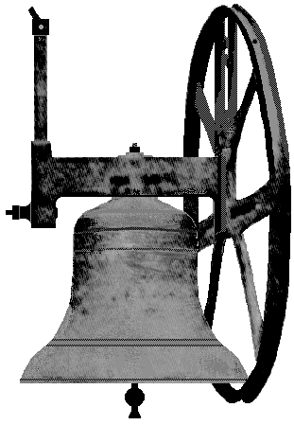
On Sunday 30 August 2020 Church Bell Ringing returned to Bulwell. For the first time since Christmas morning, last year, we rang our bells for the morning service. The ringing is limited to four bells only, these are on alternate and not adjacent ropes. The ringing is limited to 15 minutes and strict safety precautions are in place for ringers ascending the tower. During the ringing only four ringers may be present and each one is allowed to ring one bell only during the session. Maximum ventilation is provided and ringers are required to wear masks. Descent of the tower after ringing is also strictly supervised. So we are now back to ringing but not as we knew it. All this and more complies with the ‘advice’ circulated weekly, by the Central Council of Church Bellringers who are liaising closely with the Church of England and therefore, through them, following Government guidelines. All this is seen as the only practical way to restart our ancient art of church bellringing safely.
THE TOWER
So far we have rung for two Sunday mornings and one wedding. On the third Sunday morning a failed door lock prevented our entry to the church tower and one bell only had to be tolled, from downstairs
In the same way that it has been done since the restart of services, after the lockdown.
We hope to continue to ring our four bells in this manner, until there is a greater relaxation of the safeguarding of ringers, when we can all, including those over 70 years, return to the tower for more normal ringing.
AN INTERESTING CHURCH BELL.
Recently in The Ringing World (the weekly magazine for bellringers) there was an article on the church bells of Thaxted, Essex. Thaxted is quite famous among Morris dancers, who hold their annual convention, in that village. There are eight bells in Thaxted church Tower. Number three bell is the justice bell, number four is the dance bell, number five bell is the peace bell and number seven bell is the craft bell. The fourth bell, being the dance bell, reflects the tradition of Morris dancing in Thaxted and carries the words, ‘I ring for the general dance’. It has around its shoulder, a motif of folk dancers, with Morris dancers and couples, in Festival dress. On one occasion I visited Cecil Sharp House, in London, which is the headquarters of the English Folk Dance and Song Society and saw in the library there a section of the pattern for the bell, which showed the dancers, these were about 4 inches high and very detailed.
Robert Naylor – Tower Captain
FACE COVERINGS
We are presently required to wear facecoverings in many places, including church. (Unless exempt for various reasons) The medical experts and health authorities do admit that these will not give us, as individuals, much protection. They do, however, stop us from breathing out droplets of moisture, which could be infected, to the detriment of the people around us.
I treat the wearing of a facecovering, as an example of Christian care for those around me and for anyone I may meet.
Robert Naylor
NOVEMBER DATES FOR YOUR DIARY
SUNDAY 1 NOVEMBER 10AM we will be remembering our departed loved ones in our special ‘Remembering our Saints and Angels’ memorial Service. All welcome. If you would like a departed loved one remembering and a candle lighting for them, please write their names on the list in church, or speak with Fr Andrew. Thank you.
SUNDAY 8 NOVEMBER is REMEMBRANCE SUNDAY.
PARISH MASS 9.30AM followed by an
ACT OF REMEMBRANCE 10.55AM outside at the War Memorial. Following conversations and advice from the Royal British Legion, this will be different from previous years due to the coronavirus restrictions, and there will be no service following on in church afterwards.
11 NOV IS ARMISTICE DAY & at 10.55AM There will be a wreath-laying ceremony with the Royal British Legion outside at the War Memorial.

FINDING GOD PART 1
Dear Readers.
This is my last article for the St Mary The Virgin & All Souls Parish Church Bulwell’s The Hill Bulwell Parish Magazine. This article will be spread across two editions of the magazine; October and November. I wanted to share my story of finding God as it may be something which could be seen as some sort of rebirth and we’re beginning to work our way towards Christmas when Jesus was born.
The biggest difficulty with writing something like this is that there will be some people who believe that I was always supposed to find God. If that is the case, I could be starting this article with my birth. I was born on the day that most of us worship, Sunday. It was a Sunday in the middle of spring. I assume it was a lovely day. Such a day’s weather should reflect the coming of such a man…or perhaps there was thunder and lightning as my mother gave birth to a cloven-hoofed heathen. Who could ever know? I think the best place to start is right after I left a job working in sales in early 2018.
I had some issues at that job right from the start. When I started that job, the end of a relationship was fresh in my heart and I was in devastated hysterics for a few days when it first came to end. I had gone to the interview for the job hoping it might restart the relationship and when it didn’t and it became clear that the relationship was done, I fell into depression. Working in that job, I worked side-by-side with the most tyrannical woman I will ever meet and being so emotionally drained, I hadn’t the efforts to keep her at bay. If I was depressed before, living in her tyranny almost buried me six feet deep. When I was sacked from that job a year after starting it, I immediately felt slightly better. I still hadn’t dealt with the breakup because the tyrannous woman’s tyranny never allowed me the energy to do so and I still had to deal with what I had been through but the fact that I no longer had to continue to experience it was something I could smile about.
Ben

WORD SEARCH
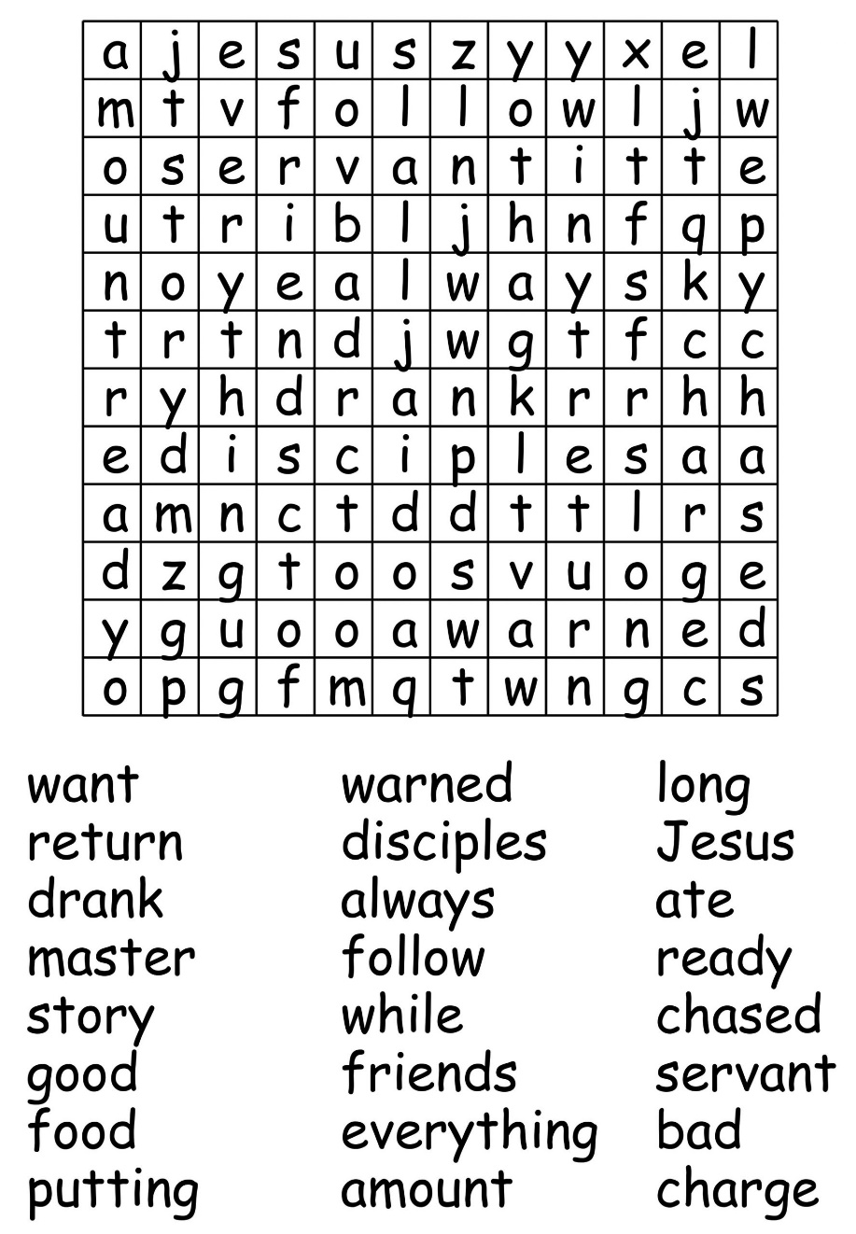

As coronavirus continues to spread throughout the world and our daily lives are changed beyond recognition, Christian Aid and our partners are still reaching out to the most vulnerable and hardest to reach communities.
CHRISTIAN AID UPDATE
On World Humanitarian Day we are honouring the tireless efforts of our local partners. They are overcoming unprecedented hurdles to provide life-saving support and protection to those who need it most.
For pictures more information and latest updates please visit the Christian aid website.

AFGHANISTAN Working through local partners is central to our emergency response project in Afghanistan and Nigeria, which is funded by UK Aid.
The project focuses on the hardest to reach communities whose lives have been impacted by conflict. Local partners with established relationships and trust in the communities have been able to make an impact quickly.
Our local partner, Afghans 4 Tomorrow (A4T), are providing accurate information about the virus and supplying water, sanitation, hygiene, food and cash support to cope with the immediate effects of coronavirus.

NIGERIA n our UK Aid funded rapid response project in Nigeria and Afghanistan, we are working through local organisations, community influencers, such as faith leaders, who are trusted and embedded in communities. This means we can connect with the hardest to reach people.
In Benue state, Nigeria, our local partner Community Links and Human Empowerment Initiative are providing essential items to communities who have been affected by conflict.

EL SALVADOR Our local partner Social Initiative for Democracy (ISD) are providing food and accurate information about coronavirus to remote communities in Community El Pinalito, in the municipality of Arambala.
Restrictions on movement has meant that people cannot get out to work. ISD are also training people in demanding their rights and advocate for changes in policies that affect them.
In addition to the countries mentioned above there is information on the website about other places, South Sudan,Cox’s Bazar, Rohingya camps,Syria, India, Myanmar, Nepal, Lebanon.

PRAYER IN TIMES OF FOOD SHORTAGES

Loving and almighty God,
We pray for all who are working to combat the growing food crisis:
For international aid agencies and local community organisations.
And in particular we pray for those in positions of power.
May the leaders of the nations act with wisdom and compassion
Bringing relief to those who suffer now
And moving us towards a world without hunger.
We pray for our sisters and brothers caught up in a cycle of drought and hunger:
for parents struggling to find food and seeing their children go hungry,
for farmers seeing their crops fail and livestock die.
We pray for ourselves:
May we share generously from the abundance that you have given us
and join our voices with those who call for an end to poverty,
that lives may be saved and rebuilt with hope for the future.
May we act in your name Lord and be an instrument of your grace.
Amen
PRAYER FOR EMARGENCIES
O God, our refuge and strength,
our help in times of trouble.
Have mercy on the lands where the earth has given way.
Have mercy on the lands where the weather has destroyed livelihoods.
Prosper those who rebuild houses,
and strengthen those who rebuild hope
so that entire communities
may face the future without fear.
Amen.
CHURCH WEBSITES AND SOCIAL MEDIA:
https://www. bulwellchurch.org.uk
https://www.achurchnearyou.com/bulwell-st-mary-the-virgin-all-souls

https://www.facebook.com/St-Mary-The-Virgin-And-All-Souls-Church-294000594473079/
You can also follow us on Twitter- @Stbulwell

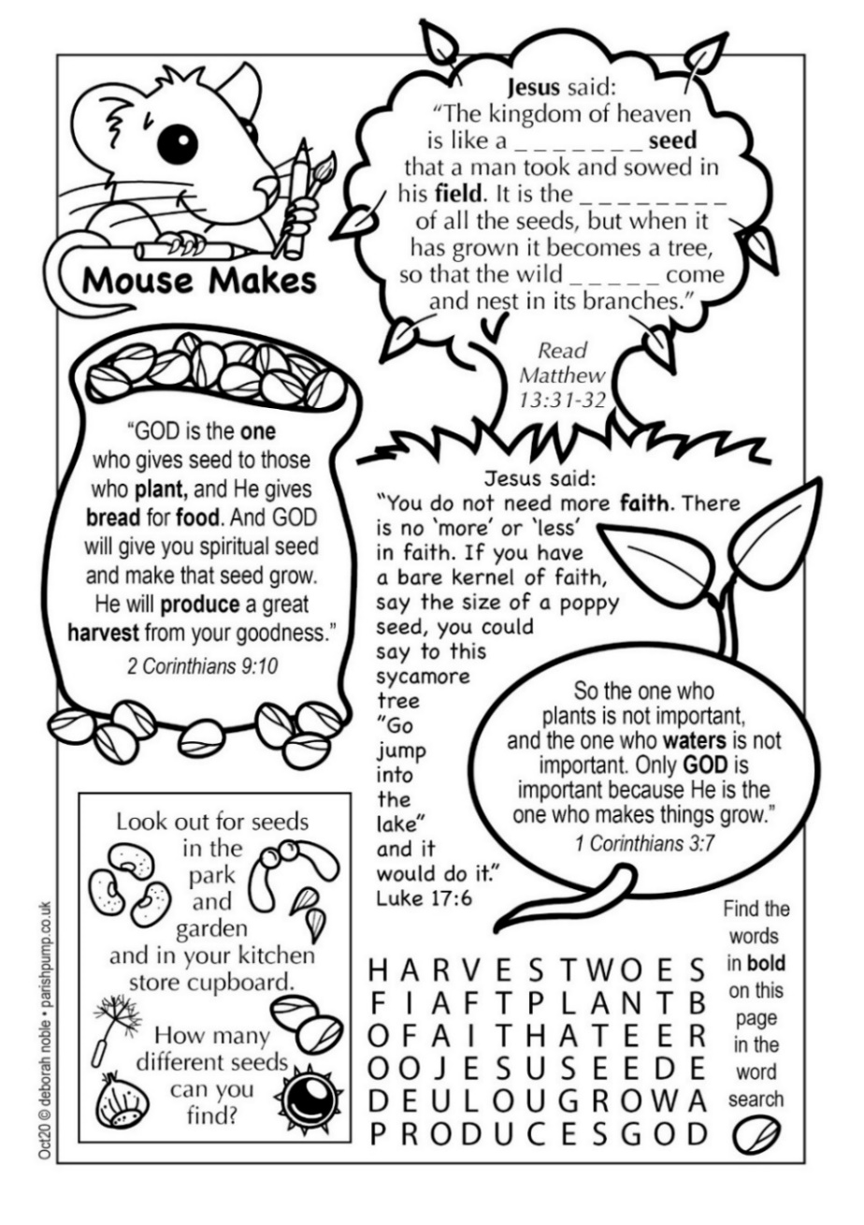

BAPTISMS
ST MARY’S PARISH INFORMATION
Saturday 12 September Lowenna Smith
Sunday 13 September Louie Hartney
We remember Lowenna and Louie, their families and god – parents in our prayers.
A large print version of this magazine is available and can be obtained, to order only, by arrangement with the Editor.
FOR YOUR INFORMATION
VICAR
Father Andrew Fisher 0115 9755358 - a.j. fisher@outlook .com
LLM (LICENSED LAY MINISTER)
Anne Elphick 0115 9267007. anne.elphick303@gmail.com
CHURCHWARDENS
Eleanor Lang 0115 9277212 ellielang@btinternet.com
Roy Hadfield 07747 015 624 royhadfield@hotmail.com
SENIOR SIDESPERSONS
Richard Shaw Rosie Cheer Martin Walton Liz Dyer
ORGANIST Philip Miles 07512 355185 pmiles2001@gmail.com
CHURCHWARDEN EMERITUS Robert Naylor 0115 9161787
TOWER CAPTAIN Robert Naylor 0115 9161787
MAGAZINE EDITOR Jillian Naylor jillian.naylor@ntlworld.com

Copy date for the November edition of The Hill is 15 October 12 noon

