PARISH CHURCH BULWELL
ST MARY THE VIRGIN & ALL SOULS
THE HILL
BULWELL PARISH MAGAZINE
SEPTEMBER 2020 Vol. 149 No 9

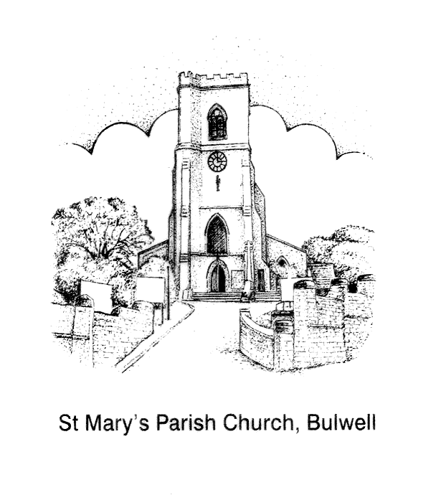

Welcome to our
HARVEST CELEBRATIONS

‘ALL GOOD GIFTS AROUND US ARE SENT FROM HEAVEN ABOVE’
Sunday 20th September
10am. Celebration Harvest Mass
Preacher/Celebrant: Bishop Paul

Followed by-
Bring a picnic, drinks and garden chairs – socially distanced in the church yard
with socially distanced fun activities - if wet in church!

DUE TO THE CORONAVIRUS RESTRICTIONS CHURCH MAY NOT BE AS BEAUTIFULLY DECORATED FOR OUR HARVEST FESTIVAL THIS YEAR, BUT YOUR GIFTS OF IN-DATE TINS AND PACKETS OF FOOD FOR THE BESTWOOD & BULWELL FOOD BANK ARE EVEN MORE VITAL – in a carrier bag, please.

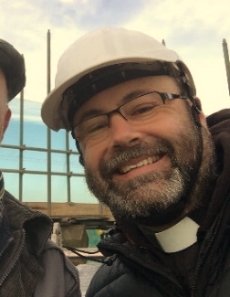
As we continue to reflect on the coronavirus pandemic, we can perhaps begin to appreciate all the planning Governments, health services, industries and faith communities have had to do over the previous months to try and keep us safe and to keep communities going.
YOUR VICAR WRITES

And as nations, businesses and people emerge from the pandemic and begin to look towards the future, we might wonder how far ahead they and we can plan for the future, or should plan, especially in vastly changing circumstances?

In Matthew 6:34, Jesus tells his followers not to “worry about tomorrow, for tomorrow will bring worries of its own.” He tells us to take time to smell the flowers! However, another familiar slogan also reminds us that those who fail to plan, plan to fail. Perhaps emotionally we can live a day at a time, but otherwise we must prepare to build the life we want to live.

So, where should we draw the line? How much of the future can we plan? How do we strike a balance? I would suggest that only through prayer and in the knowledge of God’s will can we get it right.

As we emerge from the pandemic, trust God to direct you, your life, your plans and your hopes. Determine what is God’s will for your life, map the route to be taken, and the steps needed for achievement. Then let God shepherd you.

“Take delight in the Lord, and He will give you the desires of your heart. Commit your way to the Lord; trust in Him, and He will act. Psalm 37:4-5”

God bless you on your journey with him.

Fr Andrew
FAIRWAY VIEW CHARITY WALK

Fairway View Care Home will be taking part in the Alzheimer’s Society Memory Walk this month. This would usually take place at Wollaton Park, but due to the current restrictions regarding coronavirus this won’t be happening this year. However, this isn’t going to stop Fairway View! So between the 4th and 11th September Fairway View staff and residents will be taking part in their own memory walk by doing laps of their garden.

Fr Andrew is going to get involved too, by doing his own walk for Fairway View in the churchyard, around the church building, after the 9.30am Walsingham Mass on Thursday 10th September. Look out for the sponsorship form at the back of church.

Why not join him for a bit of gentle cardio and a giggle?! (socially-distanced of course!)

All proceeds will go towards the Alzheimer’s Society and Fairway View’s Residents Fund.
Following the 10am Mass, Sunday October 25th. Everyone who is on the church Electoral Roll is welcome to attend. The APCM is an opportunity for us to reflect on the past year at St Mary’s, and to think and pray about our future.
ANNUAL PAROCHIAL CHURCH MEETING (APCM)

"The Parochical Church Council is made up of the Priest, Licenced Readers, Church Wardens, elected members, and Deanery Synod representatives. The PCC meet every other month or sooner if necessary to discuss and make decisions regarding the running of the church. PCC members are elected at the APCM. This would normally be for a period of 3 years. Also elected are Deanery Synod representatives.

The PCC discuss and make decisions on all aspects of church life. This will include worship and evangelism, all financial and legal matters, upkeep of the church, social activities, children and youth, and safeguarding. Sub committees cover each area in between PCC meetings and report back to the PCC for further discussion if necessary.

To be a member of the PCC members must be a communicant and have habitually attended this church for a period of 6 months prior to the APCM and be included on the electoral roll again for a period of 6 months prior to the APCM.

Each applicant must be nominated and seconded prior to the APCM meeting before the meeting and subsequent election.

If you are interested in putting yourself forward, please speak to Fr Andrew or one of the church wardens.

Carole Jackson - PCC Secretary
ELECTORAL ROLL
Any member of the congregation wishing to become a member of the Church Electoral Roll ( please note: this is entirely separate to the Government Electoral Roll and pertains to St. Mary's only) may apply to do so, provided they meet the following main criteria:

-a person is a member of the Church of England and has been baptised
- is of sixteen years of age or upwards
-has signed an application form for enrolment
-where a person is not resident in the parish they must have habitually attended worship during a period of six months prior to enrolment.

Application forms may be obtained from me in person or I am happy to forward application forms by email if easier.
Thank you.
Sam Reynolds - Electoral Roll Officer
samreynolds201@btinternet.com
KRAFTY KIDS at ST MARY’S C of E PRIMARY SCHOOL
Krafty Kids is not able to resume for the foreseeable future due to the coronavirus restrictions. Please watch this space for more information, and we hope that things will be able to return to normal before too long.
BIBLE STUDY MESSAGE FROM ANNE ELPHICK
The Tuesday Bible Study group will not start up again until later in the autumn. Four of the members have chosen to continue to shield
BESTWOOD & BULWELL FOODBANK
During the lockdown the opportunity was given for folk to bring any food or toiletry donations for the Foodbank to the Rectory for Fr Andrew to take to the Foodbank, or for individuals to make a monetary donation online. No food or toiletries donations were forthcoming. Now the church is open again for worship, please bring any food and toiletry donations to church. As more and more people are made redundant because of the pandemic, the more our Foodbanks will be needed. Thank you.
A REQUEST ……………….
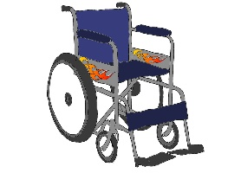
This Photo by Unknown Author is licensed under CC BY-SA-NC
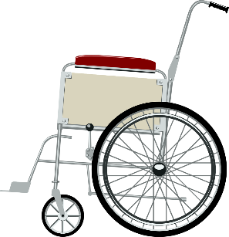
If anyone reading this request or knows of anyone, who has an unused wheelchair either to loan to church or to donate to church, it would be gratefully received. Please get in touch with Fr Andrew or one of the Churchwardens, Eleanor Lang or Roy Hadfield, who could arrange for collection.

EMAIL SCAM AIMED AT CHURCHES
Nottingham North Deanery have been informed of an email scam purporting to be from clergy, asking for someone at church to buy Amazon cards.
The email address is churchonline948@gmail.com. The body text of the message says;
I need 6 qty of Amazon gift card £100 value on each (total £600) you should get them at any store around you. After you get them scratch the back and take a clear pictures of each card and send to me on here. I will handle the disbursement. Please keep the physical cards and receipt for reference purpose. You will be reimbursed. Thanks.
The imposter quotes from the Bible and clearly knows the names of church administrators and vicars so has done the homework needed to try to deceive people.
DAILY SERVICE OF HOLY COMMUNION AT THE CATHEDRAL
Southwell Minster's doors are open every day between 11am and 3pm for visitors and for private prayer. All necessary guidance and advice has been followed to maintain social distancing and hygiene measures.
There is a short service of Holy Communion every day Monday–Saturday at 1.15pm. There is no need to book for this service.

Since the article “Is God Dead?”, I’ve been thinking a lot about Nietzsche’s claim that God is dead and the consequences of such. Coming out of the consequence that God is dead means that humans are free to create their own system of morality, therefore pursue their own paradise on earth. However, as evidenced by every attempt humans have ever made, paradise or utopia on earth seems unlikely. Some examples of the attempts of the utopia are a 75% food production fall leading to mass starvation under Chavez and Maduro in Venezuela, the gulags of the Soviet Union, and more recently the persecution of the Uyghur Muslims in Communist China. Why does this seem to occur in human-led paradises?
ONE STEP FURTHER FROM HELL

I’ve heard and read many arguments comparing human beings to gods and this is partially true. As humans become better and better at producing and creating, the comparisons to gods are warranted especially as the rise of artificial intelligence comes closer and closer. If we are comparable to gods in our creativity, why is it that we cannot seem to create a paradise as God did?

We had the Garden of Eden where Adam and Eve lived before being tempted to eat the forbidden fruit from the forbidden tree. This was paradise on earth. Adam and Eve were thrown out of the garden and doomed to till the ground with no guarantee of yield. I think that the key difference between the human ‘gods’ of today and the God who created the true paradise is that humans lack the objective morality of God. We are flawed and this is evidenced by humans corrupting the Garden of Eden. It seems that humans are the corrupting factor in all attempts of paradise whether created by humans or involved with humans.
If humans cannot achieve paradise due to their proclivity towards corruption, surely humans are destined to move the world to the gates of hell itself? Not necessarily. Since we are conscious and aware of the future, something unique to humans, we are equipped of some knowledge of the consequences of our actions. We have the ability to recognise whether our actions may have bad outcomes.
To take steps towards heaven seems to be too specific an objective to keep human corruption at bay but the opposite of hell doesn’t necessarily have to be heaven. What if the opposite of hell that humans should work towards is not hell? Perhaps that is unspecific enough that human corruption cannot weave all of its tentacles into. This is the conclusion I’ve drawn based on my thoughts of Nietzsche’s declaration. Perhaps it is our duty to not do bad as a minimum expectation, and to remove the bad from our societies. Instead of pursuing a ‘good’ society which could go so badly as it seems to regularly, we should try not to be a bad society. Perhaps that’s the best humans could wish for. One step further from hell.
Ben.
SAMMY THE SNAKE
Have you been to see Sammy the Snake on the path around St Mary’s Church? Sammy is made up of decorated stones either painted or decorated with stickers. It is a community project, and anyone is welcome to bring a stone to contribute to Sammy, or just to come and have a look at those already there, it may give you some ideas, other ideas can be found on the internet. Acrylic paint is waterproof and can be used, felt tips can be used or anyone can have their own ideas. Why not give it a try?
Below are example of stones already contributed.

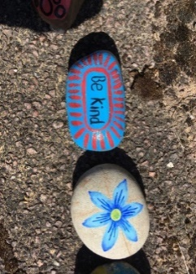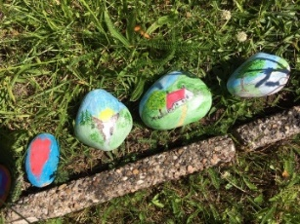

THE TOWER
It is now some seven and a half months since we last rang for a service at Bulwell. That was way back on Christmas morning. We finished so the builders could take over the tower for re- roofing and stonework repairs.

Since then, the Corona Virus pandemic has created lockdown, which delayed the repairs and our return to ringing. All is now clean and tidy and we are ready to go, but have been awaiting advice from the Central Council of Church bellringers, who in turn have been taking advice from the Church of England, who in their turn have been consulting with the Government.

All towers in this country, now have permission to ring, but it is ringing not quite as we knew
it. We must act on the advice given.

We are required to discourage members over the age of 70 years from ringing and all
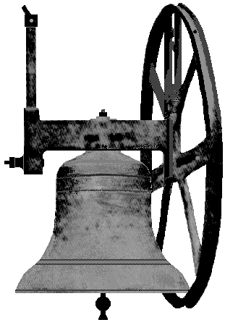
ringers must wear masks when in the tower. All available opening windows must be opened to increase ventilation, and ringers must maintain the required minimum 2 metres social distancing. Because of the closeness of our ropes this means that for the foreseeable future we will only be ringing bells numbered 1 – 4 – 6 – 8. We are advised that this combination will produce the nicest sounding four bells, while maintaining the required distances.

Ringers will ascend the tower stairs one at a time to more easily maintain spacing. Hands will be sanitised both before and after ringing. Each ringer will ring only one bell and be responsible for that bell during the entire session. For the sake of safety sessions will only last for 15 minutes. This is all very unsatisfactory but is the best we can do with the advice available.
A full risk assessment has been made available to all ringers.

We plan to start our ringing for Sunday service on 30 August. This will be followed by ringing for a wedding at 2pm on Saturday 5 September. Providing the same four ringers are available, we shall be able to ring for Sunday service the following day. Any change to the team would require a 72 hour clearance period before any further ringing could take place.

Robert Naylor - Tower Captain

GOOD NEWS

I am delighted to announce that Darren Wilkinson, whose placement at St Mary’s over Holy Week and Easter was cut short by the coronavirus and ensuing lockdown, has been accepted by the Bishop for licencing as an Licensed Lay Minister (LLM) this Autumn. Darren’s LLM cohort is beginning at Southwell Minster in October. Our prayers and blessings go with Darren as he begins this next phase of his ministry. Fr A
THE MOST POPULAR BIBLE VERSES

BibleGateway listed the most viewed or searched-for Bible verses for 2019. As it happens, five of the top ten verses were from Psalm 23, demonstrating the Psalm's popularity, not only among Christians, but perhaps also among those who hear the Psalm at funerals or other events within the Church. If you added up all the usage percentages, Psalm 23 would be the most popular Bible passage of 2019 on this largely web-based platform.
If we give only one mention to Psalm 23, then the most popular Bible verses were:
1. John 3:16 For God so loved the world that he gave his one and only Son, that whoever believes in him shall not perish but have eternal life.
2. Jeremiah 29:11 For I know the plans I have for you,” declares the Lord, “plans to prosper you and not to harm you, plans to give you hope and a future.
3. Philippians 4:13 I can do all this through him who gives me strength.
4. Psalm 23:4 Even though I walk through the darkest valley, I will fear no evil, for you are with me; your rod and your staff, they comfort me. (The other verses from this Psalm were 6, 5, 1 and 10.)
5. Romans 8:28 And we know that in all things God works for the good of those who love him, who have been called according to his purpose.
6. Romans 2:2: Do not conform to the pattern of this world, but be transformed by the renewing of your mind. Then you will be able to test and approve what God’s will is - his good, pleasing and perfect will.
7. Matthew 6:33 But seek first his kingdom and his righteousness, and all these things will be given to you as well.
8. Isaiah 41:10 So do not fear, for I am with you; do not be dismayed, for I am your God. I will strengthen you and help you; I will uphold you with my righteous right hand.
9. Philippians 4:6 Do not be anxious about anything, but in every situation, by prayer and petition, with thanksgiving, present your requests to God.
10. John 14:6 Jesus answered, “I am the way and the truth and the life. No one comes to the Father except through me.
ST MARY’S PARISH INFORMATION

FOR YOUR INFORMATION
VICAR
Father Andrew Fisher 0115 9755358 - a.j. fisher@outlook .com
LLM (LICENSED LAY MINISTER)
Anne Elphick 0115 9267007. anne.elphick303@gmail.com
CHURCHWARDENS
Eleanor Lang 0115 9277212 ellielang@btinternet.com
Roy Hadfield 07747 015 624 royhadfield@hotmail.com
SENIOR SIDESPERSONS
Richard Shaw Rosie Cheer Martin Walton Liz Dyer
ORGANIST Philip Miles 07512 355185 pmiles2001@gmail.com
CHURCHWARDEN EMERITUS Robert Naylor 0115 9161787
TOWER CAPTAIN Robert Naylor 0115 9161787
MAGAZINE EDITOR Jillian Naylor jillian.naylor@ntlworld.com

A large print version of this magazine is available and can be obtained, to order only, by arrangement with the Editor.
Copy date for the October edition of The Hill is 15 September 12 noon

AN INTERESTING CHURCH BELL.
As many of you know Robert is a bellringer.
Recently in The Ringing World (the weekly magazine for bellringers) there was an article on the church bells of Thaxted. Thaxted is quite famous as the Morris ring meet there annually There are eight bells in Thaxted church Tower. No three bell is the justice bell, no four is the dance bell, no five bell is the peace bell and no seven bell is the craft bell. The fourth bell, being the dance bell, reflects the tradition of Morris dancing in Thaxted and carries the words, ‘I ring for the general dance’ it has around its shoulder, a motif of folk dancing , with Morris dancers and couples, in Festival dress. On one occasion we visited Cecil Sharp House and Robert reminded me that in the library, on display, was part of the pattern, which showed the dancers, as seen on the bell.

