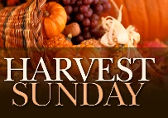
Sunday 20 September – HARVEST FESTIVAL
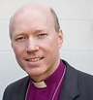
9.30am Bellringing
10am Harvest Mass with Preacher/ Celebrant the Rt Revd. Bishop Paul Williams the Bishop of Southwell & Nottingham.
Bible Reading: Matthew 6:25-34
Following the service Bishop Paul will be blessing the tower now the work has been completed.
The service can also be followed on our Facebook Page and church website. Please bring any in-date tins or packets which will be donated to the Bulwell & Bestwood Foodbank. The planned picnic afterwards is cancelled due to the Government ‘Rule of Six’ restriction.

The Bestwood and Bulwell Foodbank has been incredibly busy - the number of children being fed has doubled. Now the church building is open again for worship, please bring any food and toiletry donations to church. As more and more people are made redundant because of the pandemic, the more our Foodbanks will be needed. Thank you.

Monday 21 September - St Matthew, Apostle & Evangelist
2.30pm St Marys School Collective worship (Fr A)
We pray for ‘Now we’re Cooking,’ our uniformed organisations, Toddler Group and other Hall users who would have been using the church building and grounds these coming weeks. We also pray for our local schools now they have reopened and for the safety of the pupils who study there and adults who work in the schools.

Tues 22 Sept – Birth of The Blessed Virgin Mary
PM Volunteer Chaplaincy at Highbury Hospital; Fr A, Anne E & Roy (TBC)
Bishop Andy will be consecrated in York Minster today by the Bishop of Durham, the Right Revd Paul Butler, assisted by the Bishop of London, Sarah Mullally and the Bishop of Southwell & Nottingham, Paul Williams.

Wednesday 23 September
Vicar Fr. Andrew Fisher MTh
0115 975 5358
a.j.fisher@outlook.com

St Mary’s Mirror Editor
Jillian Naylor 0115 9161787 jillian.naylor@ntlworld.com

W/c Sunday 20 Sept 2020
bulwellchurch.org.uk

www.bulwellchurch.com

Anne Elphick day off emergencies, only please
10.30am LLM 1:1 (Roy & Fr A at the Rectory)

Thursday 24 September
9.30am Walsingham Mass
10am Worship PCC Sub-Committee Meeting (Fr
A, Roy, Anne E, Philip M, Kerry)
11am Hall Park Care Home - Service TBC 7.30pm Bulwell Churches Together meeting
(The Well) TBC
We pray for the staff and residents of our local care homes and sheltered housing complexes as St Mary’s visits have restarted (virtual or otherwise!).

Friday 25 September
Clergy day off emergencies only please
No Walsingham Pilgrimage due to coronavirus

Saturday 26 September
No Walsingham Pilgrimage due to coronavirus

Sunday 27 September Trinity 16
9.30am Bellringing
St Mary’s Mirror
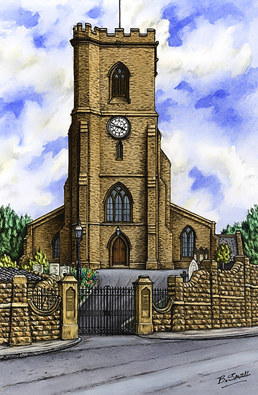

10am Parish Mass (Said)
Bible Readings: Ezek 18:1-
4, 25-end, Phil 2: 1-13,
Matt 21. 23-32
The service can also be followed on our Facebook Page and Website.
4pm Evening prayer led by Fr A
No Walsingham Pilgrimage due to coronavirus
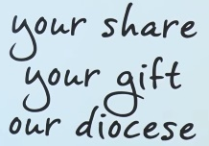
Our outgoings far exceed our current income and we are nowhere near meeting our requested Parish Share for this year of £24996.00. Currently it is likely that we will only be able to pay half the figure (£12,000) …
FROM OUR TREASURER

In past editions of the Hill and St Marys’ Mirror it has been suggested how donations to St Marys can be made to support our ongoing mission and ministry, even through these extraordinary times. Whilst we haven’t had our Sunday Service collections in church until recently, and cannot hold our usual Fayres and fundraising activities, our mission and ministry costs go on. Many people have standing orders set up, for which we are very grateful. This remains a great way to donate. A standing order form can be supplied if required. Here is a reminder of the other options available:

- St Mary’s now has an account on the ‘Give A Little’ website which can be accessed at

https://givealittle.co/campaigns/ec595deb-2497-4010-8bd2-91d67f3dc088

You can donate as you require using any bank card. You can also sign up for gift aid to be added to your donation if that is appropriate. You can also request a receipt.

- If you use online banking and want to make a bank transfer, please make the Donation to this bank account – Bulwell Parochial Church Council, Sort 40-35-12, Acc: 21456717.

- If you do not have the use of the internet then you can send cheques made payable to ‘Bulwell PCC’ and post via Fr Andrew at The Rectory, Station Road, Bulwell, Nottingham, NG6 9AA

- In addition we are working on implementing a Paypal account which will be available on our website. If you have either a PayPal account or a bank card is to go to the website: www.bulwellchurch.org.uk and click on the Donate button.

Thank for your prayers and for continuing to keep in touch with one another. We are a community of caring souls. Bless you all.
Peter Stanley (Treasurer)

Between the 4th and 11th September Fairway View staff and residents took part in their own memory walk by doing laps of their garden, raising money for the Alzheimer’s Society and Fairway View’s Residents Fund. St Mary’s own Jackie Bramford and Fr A got involved too, Fr A doing his own walk for Fairway View around the church and churchyard after the 9.30am Walsingham Mass Thursday 10 September. Rev Bob, Sheila Riddell, Jackie Habegger and Carol Ezard supported the event and joined in for a bit of gentle cardio and a giggle (socially-distanced of course!) £35 was raised for the charity and Fairway View. Many thanks to those who sponsored Fr A.
Have you seen Sammy the Snake on the path around St Mary’s Church? Sammy is made up of decorated stones either painted or decorated with stickers. Anyone is welcome to bring a stone to contribute to Sammy, or just to come and have a look at those already there, it may give you some ideas.
The Tuesday Bible Study Group will be starting up – but no date available. Please see Anne Elphick, our Licensed lay Minister, for more info.

ANNUAL PAROCHIAL CHURCH MEETING (APCM) Sunday 25 October following the 10am Parish Mass. Everyone who is on the church Electoral Roll is welcome to attend. The APCM is an opportunity for us to reflect on the past year at St Mary’s, and to think and pray about our future. More information in September edition of The Hill. Any member of the congregation wishing to become a member of the Church Electoral Roll may apply to do so, provided they meet the criteria listed in the September issue of The Hill. Application forms may be obtained from Sam Reynolds, Electoral Roll Officer:
samreynolds201@btinternet.com
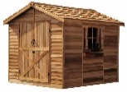
Government guidelines permitting, “Men in Sheds” will be starting 10.30am – 3pm at St Mary’s Church, Tuesday 29 Sept. Men in Sheds is a ground-breaking project for older men. Activities include woodworking, skills sharing and socialising and is for anyone who wants to get together, share and learn new skills. It also supports older men who are isolated or disengaged from their community or are experiencing major changes in life. Why not come along or invite somebody you know?

The Deanery Confirmation Service will be held at St Margaret’s Aspley 6pm November 15, and we pray for our congregation members Karen Brett and Lee Nolan who will be getting confirmed during the service. If you would like to be Confirmed, please speak with Fr Andrew.

Nifty Notes are only available online at the moment because of the coronavirus. Paper copies will resume as soon as they become available again to hand out.

