ST MARY THE VIRGIN & ALL SOULS
BULWELL PARISH MAGAZINE
THE HILL
January 2021 Vol. 150 No 1

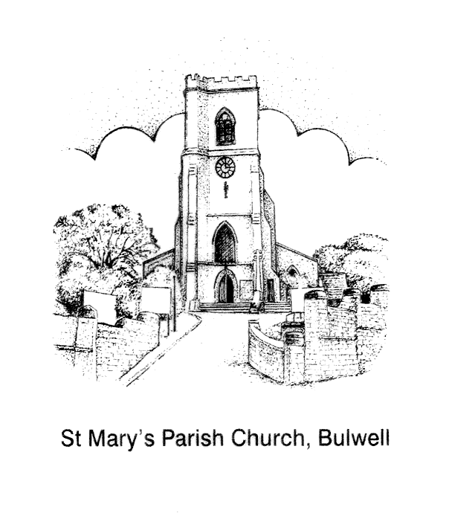

After the long delay due to lockdown, Bishop Tony and Lucille are now proud owners of the framed painting that was commissioned for their retirement gift. The painting, by local Southwell artist, Christine Measures, depicts some of the many areas of ministry that +Tony and Lucille were involved with during the fourteen years that they served in the diocese.
CONTINUING TO SCATTER THE SEED OF THE GOSPEL IN RETIREMENT

True to style, +Tony and Lucille are settling in and beginning to make connections in the Diocese of Blackburn, where they have been warmly received.

Bishop Tony writes: “The beautiful painting by Christine Measures brings back wonderful memories of fourteen happy years in the diocese. We are happily settled in Leyland, where we love zooming....to the seaside for fish and chips.

We are deeply grateful for your kindness and generosity”. God bless, Bishop Tony and Lucille (churchofengland.org)
BESTWOOD & BULWELL FOODBANK
Food distribution takes place in the West Room at St Mary’s 1pm -3pm Wednesdays starting January 5 (after the Christmas break). For voucher holders.
To help safeguard service-users and to maintain social-distancing, please can church officers, users and volunteers avoid entering/using the church and west room whilst the Foodbank is in operation; or contact the Foodbank in advance if your work is urgent and cannot be done at any other time. Thank you for your cooperation, Fr Andrew.
Contact details:
Nigel Webster info@bestwoodbulwell.foodbank.org.uk 0115 9751825
YOUR VICAR WRITES
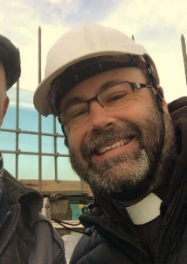
Dear Readers

It was lovely to see so many people coming to worship at St Mary’s following the second lockdown in December. The church building has seen some sights over the last 170 years or so, I’m sure, not least of all the coronavirus pandemic. I wonder, if its stones could talk, what would the building say?

I’d like to share with you a piece written by the Rt. Revd. Neville Gorton, who was Bishop of Coventry between 1943-1955:

A Parish Church Speaks (18th June 1954)

“I am a person, I grew as you grow, created by love out of love to speak with my children and they to me, and in a threefold conversation with God. I have spoken to my children and they to me over hundreds of years about love and death, marriage and children, suffering and joy. Every part of me; altar, roof, sanctuary, font, the stones themselves are my organs of speech. I have spoken to my children, and they to me. I am old in wisdom and the interchange of love within my walls; all that has happened between me and my children and the Infinite God exists as a spiritual reality, more real than any material event.

Pull me down and let me die if I am to be treated, with my children round me, as an historical monument by the National Trust; but if you do love me and care for me as a mother of father in Christ, here to speak to you in my own speech as I have for centuries to children of God, then care for me again in that spirit and I shall be happy to go on, renewed from within as well as from without. But don’t keep me going as a shell of antiquity, as a possession of cultural interest, or as an ancient monument. I would prefer my roof to burn down, the grass to thrust up my chancel, and – what is it from the Bible about a sparrow finding a nest? “In thy altars” – in my altars, Lord God! I would rather share my end with God’s humblest creatures.”

This New Year, with an end of the pandemic in sight, why not resolve to begin, or renew, your relationship with St Mary’s?

God bless you this New Year.
Fr Andrew

“Even the sparrow has found a home, and the swallow a nest for herself, where she may have her young- a place near your altar, LORD Almighty, my King and my God.” Psalm 84:3
HONORARY ASSOCIATE MINISTER
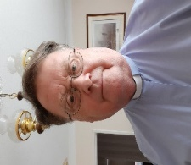
Hello, my name is the Reverend Robert (Bob) Stephens, and my wife Sue will be joining the team at St. Marys as from 01st of January 2020 and will be part of the team as Honorary Associate Minister (Retired).
I am married to Sue, and we have a son and daughter- in- law and a grandson who is taller than me and is at present working on the railways. Some of you may have already seen me helping in the interregnum and covering while Father Andrew is on leave as well as Governor at St. Marys Primary School.
So where did it all start, I was born in West London, lived most of my early years in Fulham, I became a Christian in 1964 and when I was 18, joined the PCC at Christ Church Fulham and through the years have served on several PCCs, youth leader, licensed as a Reader in 1987. In 2008 I was accepted to be trained as a priest in the C of E and was ordained in 2010 and recently retired from St. Johns Bulwell in October 2020.
My background is mainly in transport, coach industry for several years then British Rail I started my Railway Career in the Booking Office at East Putney, Paddington, Swindon, Reading and moved to Nottingham in 1982 then Birmingham, and Derby, until 2000 when I was made redundant, then three years at Nottingham Trent University leaving with a degree in Social Sciences and now an Alumni Fellow of NTU also supporting the John Van Geest Cancer research unit at NTU.
After my first wife Barbara died, I met Sue and we were married in 2014, she is an Arnold girl and I learn a lot of phrases us southerners cannot fathom, in my spare time I am maker of model buses, still keen on railways, especially railways of Switzerland, Transport historian, birdwatching and photography, also a researcher in the history of Big Bands of the 40’s. We look forward to joining you as part of the ministry at St. Marys and the community in Bulwell. Two bits of trivia, I was a guide at the London Transport Museum and have passed my tram driving test on the Seaton Tramway. We look forward to getting to know you and being part of the family at St. Mary’s
FROM THE SOUTHWELL & NOTTINGHAM PRAYER DIARY
The Diocese remembers on Thursday 07 January - Bulwell St Mary’s C of E Primary School Headteacher: Claire Godfrey
Accompanying each local prayer suggestion is always one for other Diocese and Churches in the World.
I have distant relatives in Birmingham Alabama, who go to the Episcopal Church there. Each year we send them a bell ringing calendar and they are very aware of the Diocese of Southwell and Nottingham, by name and by parish churches. A couple of years ago they were quite thrilled to tell me that the Diocese of Southwell & Nottingham had been mentioned in their prayers at church, and of course they recognised the name of the Diocese from the bellringing calendars we have sent them.
January Nifty Notes is available online on the Diocese website.

THE BLACKSMITH’S WORKSHOP

In the shop of a blacksmith there are three types of tools. There are tools on the junk pile; outdated, broken, dull and rusty. They sit in cobwebbed corners, useless to their Master, oblivious to their calling. There are tools on the anvil; melted down, molten hot, mouldable, and changeable. They lie on the anvil, being shaped by their master, accepting their calling.
There are tools of usefulness; sharpened, primed, defined and mobile. They lie ready in the blacksmith’s tool chest, available to their master, fulfilling their calling. Some people lie useless: lives broken, talents wasting, fires quenched, dreams dashed. They are tossed in with the scrap iron, in desperate need of repair, with no notion of purpose.
Others lie on the anvil: hearts open, hungry for change, wounds healing, and vision clearing. They welcome the painful pounding of the blacksmith’s hammer, longing to be rebuilt, begging to be called. Others lie in their Master’s hands: well - tuned, uncompromising, polished, and productive. They respond to their master’s forearm, demanding nothing, surrendering all.
We are all somewhere in the blacksmith’s shop. We are either on the scrap pile, in the master’s hands, on the anvil, or in the tool chest. Some of us have been in all three. From the shelves to the workbench, from the water to the fire; I am sure that somewhere you will find yourself.
The apostle Paul spoke of becoming ‘an instrument for noble purposes.’ And what a becoming it is! The rubbish pile of broken tools, the anvil of recasting, the hands of the Master. It is a simultaneously joyful and painful journey. And for you who make the journey, who leave the heap and enter the fire, dare to be pounded on God’s anvil, and doggedly seek to discover your own purpose; take courage, for you await the privilege pf being called ‘God’s chosen instruments’.
From my files of reflections, Anne Elphick
ANNOUNCEMENTS FROM BISHOP PAUL
FIVE NEW CANONS with experience on the frontline of ministry in local churches, the media, ecumenical partnership and social transformation, have been appointed by Bishop Paul to serve as Honorary Canons of the Cathedral Church of Southwell Minister.
The new Honorary canons will be the Revd Angela Fletcher, Vicar of Warsop with Sookholme and former Area Dean of Mansfield, the Revd Kate Bottley, radio and television presenter and Associate Priest of St Saviour’s, Retford, Bishop Pangani Thipa, Senior Pastor and National Overseer of the Calvary Family Church (CFC) and trustee of Refugee Roots in Hyson Green, the Revd Dr Stephen Hippisley-Cox, Vicar of Willoughy-on-the-Wolds with Wysall and Widmerpool and Area Dean of East Bingham, and the Roman Catholic Bishop of Nottingham, the Right Revd Patrick McKinney.
While continuing in their present ministries, the role of an Honorary canon is to contribute to the life of the cathedral through promoting its mission across the diocese and by connecting with wider communities across Nottinghamshire. Honorary canons are appointed by the Bishop for a seven-year term in consultation with the Dean of Southwell, the Very Revd Nicola Sullivan.
The Cathedral Church of Southwell’s College of Canons has 16 Lay and Ordained members from all walks of life, reflecting a broad range of experience, with some from other Christian denominations.
Speaking about the new appointments, Bishop Paul said:-
‘I am delighted that five new Honorary Canons are to be welcomed as members of the College of Canons of the Cathedral Church here in Southwell. Angela, Kate, Stephen, Bishop Thipa and Bishop Patrick will each bring significant experience and insight on the mission of the Church from their rich and diverse experience, as well as their engagement in supporting the ministry of the wider church in the diocese and beyond’. The new Canons will be collated and installed in Southwell Minster in Spring 2021.
THE RT REVEREND PATRICK HARRIS, 9TH BISHOP OF SOUTHWELL BETWEEN 1988 AND 1999 It is with great sadness I write to share with you that he died peacefully on the 26th December following a short illness, aged 86 years.
Bishop Patrick is held in deep affection by many across this diocese and in the wider Church. His ministry was marked by a joyful commitment to Christ and gospel growth – in lives and in churches – as well as his pastoral heart and vision for the unique mission of every local church. He remained prayerfully and closely engaged in world mission, especially in Northern Argentina where he had first served as a bishop. He never ceased praying daily for this diocese too.
Above all, the lasting impression of Patrick’s ministry in this diocese and in his retirement was his prayerful and gracious resolve to make Christ known – he remained an evangelist at heart and had no greater joy than seeing people come to Christ and in equipping others to do the same. In this, Valerie was a tremendous support and co-partner in the gospel.
I am sure you will join me in holding Valerie, their children Rachel, Jonny and David, and grandchildren, in your prayers as they grieve the loss of a much-loved husband, father and servant of Christ. With every blessing +Paul
THE TOWER

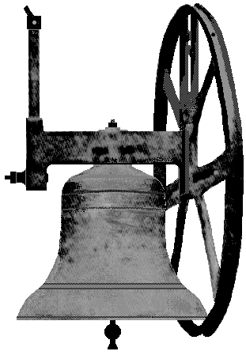
Tier 3 restrictions remained in place over the Christmas period and the five-day relaxation period, was reduced to one day. The restrictions, on ringing, by anyone 70+ meant that we could only raise two ringers for the Christmas morning service. Two bells are a poor number to ring, so we reverted to the normal tolling of a single bell. This is in line with the advice and restrictions currently in force. It is carried out by a single person in isolation and downstairs. My thanks go to Karen Wolf and Christopher Guy, who between them are maintaining this ringing for both the Sunday morning and Thursday morning services. Thanks again to you both.
Robert Naylor – Tower Captain
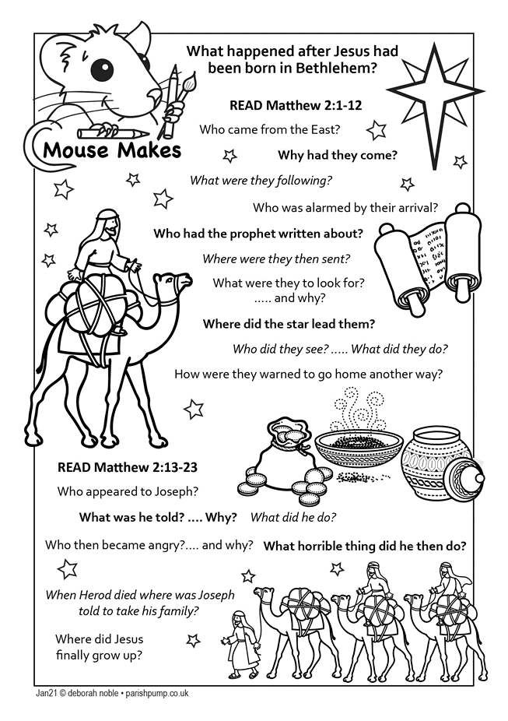
ST MARY’S PARISH REGISTERS & INFORMATION
VICAR
Father Andrew Fisher 0115 9755358 - a.j. fisher@outlook .com
HONORARY ASSOCIATE MINISTER
The Revd Bob Stephens 07775 422260 – revbob63@sky.com
LLM (LICENSED LAY MINISTER)
Anne Elphick 0115 9267007 - anne.elphick303@gmail.com
CHURCHWARDENS
Eleanor Lang 0115 9277212 ellielang@btinternet.com
Roy Hadfield 07747 015 624 royhadfield@hotmail.com
SENIOR SIDESPERSONS
Richard Shaw Rosie Cheer Martin Walton Liz Dyer
ORGANIST Philip Miles 07512 355185 pmiles2001@gmail.com
CHURCHWARDEN EMERITUS Robert Naylor 0115 9161787
TOWER CAPTAIN Robert Naylor 0115 9161787
MAGAZINE EDITOR Jillian Naylor jillian.naylor@ntlworld.com
Visit us online at:
https://www.bulwellchurch.org.uk
https://www.achurchnearyou.com/bulwell-st-mary-the-virgin-all-souls
https://www.facebook.com/St-Mary-The-Virgin-And-All-Souls-Church-294000594473079/
A large print version of this magazine is available and can be obtained, to order only, by arrangement with the Editor. Copy date for the February 2021 magazine is January 15 (12 noon)

