THE SUNDAYS AFTER EASTER

‘Jesus Christ … is alive and reigns’
It has been said that Christians are ‘an Easter people, and Alleluia is their song.’ Why? Because the resurrection of Jesus Christ from the dead gives them the hope that, in all circumstances, however dire, God works for good. The Bible readings after Easter describe encounters between the risen Christ and his disciples, in which their fears and unbelief gave way to new faith, hope and joy.

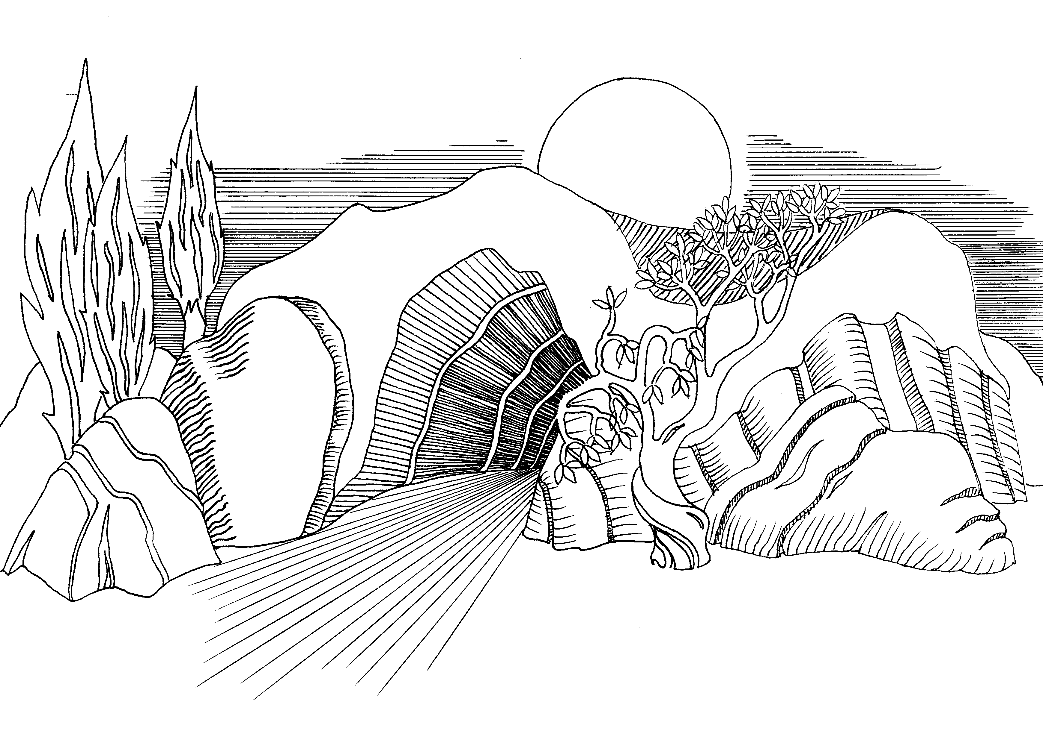
The Gathering
THE GREETING  Alleluia! Christ is risen.  He is risen indeed. Alleluia!  Blessed be the God and Father of our Lord Jesus Christ!  By his great mercy he has given us a new birth into a living hope  through the resurrection of Jesus Christ from the dead.  Through him you have come to trust in God,  who raised him from the dead and gave him glory,  so that your faith and hope are set on God. (1 Pet. 1:3, 21)  OPENING PRAYER  Lord Jesus Christ,  risen from death to life in the Father’s love,  raise us to share in the new life, that we  may know your presence among us now,  and serve you in the power of the Spirit.  Amen.  PENITENCE  ‘The doors of the house where the disciples had met were locked for fear of the Jews; Jesus came and stood among them  and said, “Peace be with you.”’ (John 20:19)  In this Easter season we bring our fears and failings to the risen Christ:  When we are faced with a challenge, but regress into old attitudes …  Lord, have mercy. Lord, have mercy. | When we allow past hurts to undermine our present relationships …  Christ, have mercy. Christ, have mercy.  When we face difficult times but fail to trust in your loving purposes …  Lord, have mercy. Lord, have mercy.  When we look inwards to our selfish concerns rather than outwards to a world in need …  Christ, have mercy. Christ, have mercy.  When we are agents of gloom rather than messengers of hope …  Lord, have mercy. Lord, have mercy.  May Almighty God have mercy on us,  forgive us our sins  and bring us to everlasting life,  through Jesus Christ our Lord. Amen.  A COLLECT FOR THE DAY  Let us pray … (silent prayer)  Almighty Father,  you have given your only Son to die for our sins and to rise again for our justification:  grant us so to put away the leaven of malice and wickedness that we may always serve you in pureness of living and truth;  through the merits of your Son  Jesus Christ our Lord,  who is alive and reigns with you,  in the unity of the Holy Spirit,  one God, now and for ever. Amen.

The Liturgy of the Word

THE SCRIPTURE READING(S)  (After the reading)  This is the Word of the Lord.  Thanks be to God.  THE GOSPEL  Hear the Gospel of our Lord Jesus Christ according to N.  Glory to you, O Lord.  (After the reading)  This is the Gospel of the Lord.  Praise to you, O Christ.  THE SERMON  AFFIRMATION OF FAITH  Let us declare our faith in the resurrection of our Lord Jesus Christ: | Christ died for our sins  in accordance with the Scriptures;  he was buried; he was raised to life on the third day  in accordance with the Scriptures;  afterwards he appeared to his followers, and to all the apostles:  this we have received,  and this we believe. (1 Cor. 15:3-7)  This is the faith of the Church.  This is our faith.  We believe and trust in one God,  Father, Son and Holy Spirit. Amen.
The Prayers
INTERCESSIONS  Our loving Father in heaven, as we recall the change that came over the disciples when they met the risen Christ on that first Easter Day, we pray for the renewal of faith, hope and love among your people today:  We pray for our fellow human beings living in fear of persecution and violence … Strengthen their hope that peace and justice will prevail. Guide our Queen and the leaders of the nations.  This Easter, Lord,  renew our hope in your victory over evil.  We pray for those who, like Thomas, struggle with doubts and hard questions … Make yourself known to them through the good news that Christ is alive, and through the witness of his followers.  This Easter, Lord,  renew us by your Spirit.  We pray for those who, like the disciples, are burdened by guilt, failure or grief … Give them a fresh awareness of Christ’s love and forgiveness.  This Easter, Lord,  renew our joy in your amazing grace. | We pray for all who are sent into the world to bear witness to Christ; for bishop N., for ministers and missionaries … Lead us by your Holy Spirit into new ways of serving you.  This Easter, Lord,  renew our commitment to your service.  We pray for those who are ill or frail … Grant them healing and encouragement.  This Easter, Lord,  renew our trust in your fatherly care.  We remember those who have died …  We join with all Christians in lifting our voices to proclaim the living Christ as  our Lord and our God. Amen.  THE LORD’S PRAYER  CONCLUDING PRAYER  God the Father, by whose glory Christ was raised from the dead, strengthen you to walk with him in his risen life.  Amen. Alleluia! Alleluia!  (A BLESSING or the GRACE is said)

