as it is in heaven.
Give us this day our daily bread and forgive us our trespasses
as we forgive those
who trespass against us.
And lead us not into temptation but deliver us from evil
For thine is the kingdom,
the power, and the glory
for ever and ever. Amen

Bible Reading
Luke 15.18–24 (the welcoming joy of God)
Responsory
Your salvation is near to those
who fear you,
All: that glory may dwell in our land.

Mercy and truth have met together;
righteousness and peace
have kissed each other.
All: that glory may dwell in our land.

Righteousness and justice are the foundation of your throne; steadfast love and faithfulness go before you.
All: Your salvation is near to those
who fear you,
that glory may dwell in our land.
Homily
Prayers
Let us pray for all who suffer as a result of conflict, and ask that God may give us peace:

For the service men and women who have died in the violence of war, each one remembered by and known to God;
may God give peace
All: God give peace

For those who love them in death as in life, offering the distress of our grief and the sadness of our loss; may God give peace
All: God give peace

For all members of the armed forces who are in danger this day, remembering family, friends and all who pray for their safe return; may God give peace
All: God give peace

For civilian women, children and men whose lives are disfigured by war or terror,
calling to mind in penitence the anger and hatreds of humanity; may God give peace
All: God give peace

For peacemakers and peace-keepers, who seek to keep this world secure and free; may God give peace
All: God give peace

For all who bear the burden and privilege of leadership, political, military and religious; asking for gifts of wisdom and resolve in the search for reconciliation and peace; may God give peace
All: God give peace

O God of truth and justice, we hold before you those whose memory we cherish, and those whose names we will never know. Help us to lift our eyes above the torment of this broken world and grant us the grace to pray for those who wish us harm. As we honour the past, may we put our faith in your future; for you are the source of life and hope, now and for ever.
All: Amen.

An Act of Commitment
Let us pledge ourselves anew to the service of God and our fellow men and women: that we may help, encourage and comfort others, and support those working for the relief of the needy and for the peace and welfare of the nations.

All: Lord God our Father,
we pledge ourselves to serve you
and all humankind,
in the cause of peace, for the relief
of want and suffering,
and for the praise of your name.
Guide us by your Spirit;
give us wisdom; give us courage;
give us hope; and keep us faithful
now and always. Amen.

O Lord our God, as we remember, teach us the ways of peace. As we treasure memories, teach us to hope. As we give thanks for the sacrifices of the past, help us to make your future in this world, until your kingdom come.
All: Amen.
Collect for Peace
Almighty God, from whom all thoughts of truth and peace proceed: kindle in the hearts of all people the true love of peace; and guide with your pure and peaceable wisdom those who take counsel for the nations of the earth; that in tranquillity your kingdom may go forward, till the earth is filled with the knowledge of thy love; through Jesus Christ our Lord.
All: Amen.

A Prayer for the Sovereign
Almighty God, the fountain of all goodness, bless our Sovereign Lady, Queen Elizabeth, and all who are in authority under her; that they may order all things in wisdom and equity, righteousness and peace, to the honour of your name, and the good of your Church and people; through Jesus Christ our Lord.
All: Amen.

The National Anthem
All: God save our gracious Queen,
long live our noble Queen,
God save the Queen.
Send her victorious,
happy and glorious,
long to reign over us,
God save the Queen!

The Blessing
God grant to the living, grace;
to the departed, rest;
to the Church, the Queen,
the Commonwealth, and all people,
peace and concord;
and to us and all his servants,
life everlasting; and the blessing of God almighty, Father, Son, and Holy Spirit, come down upon you and remain with you always.
All: Amen.

Folk are invited to join in our Sunday services from their own homes at 10am. The services can be viewed on YouTube:

https://www.youtube.com/watch?v=0B9JmOc61sA

Resources for prayer and worship can be found at:

https://www.achurchnearyou.com/bulwell-st-mary-the- virgin-all-souls

https://www. bulwellchurch.org.uk
St Mary the Virgin & All Souls, Bulwell

A SERVICE FOR VE DAY
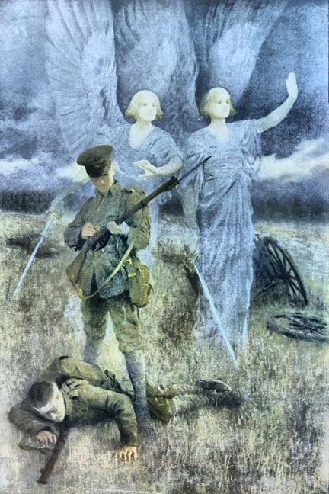
The Greeting and Introduction
Dear friends, we have come together on this day to commemorate the 75th anniversary of Victory in Europe, when the sounds of war fell silent on this continent. We come together conscious of our need for God’s forgiveness for the sin and the desire to dominate others that leads to conflict between people, and war between nations. And as we remember the many soldiers, sailors, and airmen who gave their lives restraining evil and opposing tyranny, so we also come in thanksgiving for the years of peace that the nations of Europe have enjoyed since the Second World War. We gather joyfully today, as those who gathered on that first Victory day, glad of each other’s company, and grateful for the laughter and love that follows times of sadness and loss. But above all things, let us pray that God’s will may be done on earth as it is in heaven, as we join our voices together and say:

All: Our Father, who art in heaven, hallowed be thy name.
Thy Kingdom come;
thy will be done on earth

