**Sunday 8 November – 3rd Sunday before Advent Remembrance Sunday**

St Mary’s Mirror

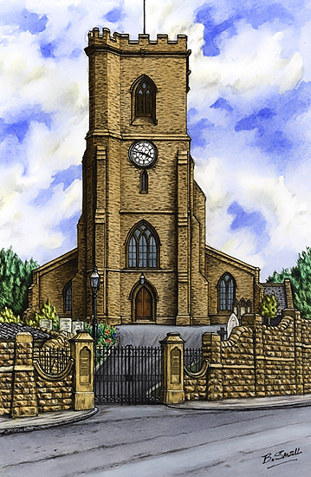

9.30am – 10.30am Church open for Individual Prayer. A pre-recorded Service will be available to watch online at: <https://www.bulwellchurch.org.uk>

10.55am Act of Remembranceoutside by the Cenotaph and War Memorials (public are politely asked to remain outside socially distanced outside the church boundary wall). No service following in church afterwards. The Act of Remembrance will be lived-streamed via our Facebook page.  A pre-recorded Act of Remembrance can be watched online at: <https://www.youtube.com/watch?v=8QftSdVLxy8>

**Monday 9 November**

St Mary’s School Collective Worship for Remembrance Sunday will be available to watch online at:

<https://www.youtube.com/channel/UCnxbQ6lU8MO6af6__K6KrAw>

**Tuesday** **10 November**

*‘Men in Sheds’ will re-commence after the lockdown, hopefully 10am – 3pm Tuesday 8th December.*



**Wednesday 11 November – Armistice Day** *Anne Elphick day off, emergencies only please*

10.55am Act of Remembranceoutside by the Cenotaph and War Memorials. (public are politely asked to remain outside socially distanced outside the church boundary wall). A pre-recorded Act of Remembrance can be watched online at:

<https://www.youtube.com/watch?v=8QftSdVLxy8>

**Thursday 12 November**

9.30am – 10am Church Open for Individual Prayer

Followed by Worship Sub-Committee meeting after (socially distanced in church)

*We pray for the staff and residents of our local care homes and sheltered housing complexes, and the visits or online ‘virtual visits’ made by St Mary’s.*

**Friday 13 November**

*Clergy day off emergencies only please.*

**Sunday 15 November – Patronal Festival**

10am – 11am Church open for Individual Prayer

Bible readings for today: Zeph 1: 7, 12-end, 1Thes 5:1-11, Matt 25: 14-30

A pre-recorded Service will be available to watch online at:

<https://www.youtube.com/channel/UCnxbQ6lU8MO6af6__K6KrAw>

Pastoral Care Sub-Committee Meeting afterwards (socially distanced in church)

*Confirmation Service at Aspley is postponed.*

*Last day for submitting items for The Hill.*

**Monday 16 November**

St Mary’s School Collective Worship (Fr A) will be pre-recorded and available to watch online at:

<https://www.youtube.com/channel/UCnxbQ6lU8MO6af6__K6KrAw>

**Wednesday 18 November**

*Anne Elphick day off, emergencies, only please*

**Thursday 19 November - Hilda Abbess of Whitby**

9.30am – 10am Church Open for Individual Prayer

**Friday 20 November**

*Clergy day off emergencies only please.*

**Sunday 22 November – Christ the King**

10am – 11am Church open for Individual Prayer

Bible readings for today: Ezek 34,11-16. 20 - 24. Eph 1 15 – to end. Matt 25, 31- end

A pre-recorded Service will be available to watch online at: <https://www.bulwellchurch.org.uk>

**Monday 22 November**

St Mary’s School Collective Worship (Fr A) will be pre-recorded and available to watch online at:

<https://www.youtube.com/channel/UCnxbQ6lU8MO6af6__K6KrAw>

**Tuesday 24November**

7.15pm for 7.30pm start. PCC meeting (socially distanced in church).

**Wednesday 25 November**

*Anne Elphick day off, emergencies only please*

**Thursday 26 November**

9.30am – 10am Church Open for Individual Prayer

**Friday 27 November**

*Clergy day off emergencies only please.*

**Sunday 29 November – Advent Sunday**

**Common Worship Lectionary Year B begins**

10am – 11am Church open for Individual Prayer

Bible readings for today: Isa. 64. 1-9, 1 Cor. 13-9,

Mark. 13. 24 - end.

A pre-recorded Service will be available to watch online at: [https://www.bulwellchurch.org.uk](https://www.bulwellchurch.co.uk)

**Monday 30 November – St Andrew’s Day**

St Mary’s School Collective Worship (Fr A) will be pre-recorded and available to watch online at:

<https://www.youtube.com/channel/UCnxbQ6lU8MO6af6__K6KrAw>

**Wednesday 2 December**

*Anne Elphick day off emergencies, only please*

**Thursday 3 December**

9.30am Walsingham Mass

**Friday 4 December**

*Clergy day off emergencies only please.*

**Sunday 6 December – Advent 2**

*8.45 am No BCP Holy Communion*

9.30am Whiz Kidz Junior Church *(TBC – See Zoe or a Whiz Kids leader for more info)*

10am Parish Mass. Bible readings for today: Isa. 40. 1-11, 2 Peter 3. 8 – 15a, Mark 1. 1 - 8

***Services and events may be subject to changes in line with Government & Church of England advice & guidance re coronavirus. Please check the church websites & social media of contact Fr A or the Churchwardens***



**Church Websites and Social Media:**

*https://www. bulwellchurch.org.uk*

*https://*[*www.achurchnearyou.com/bulwell-st-mary-the-virgin-all-souls*](http://www.achurchnearyou.com/bulwell-st-mary-the-virgin-all-souls)

# [*https://www.facebook.com/St-Mary-The-Virgin-And-All-Souls-Church-294000594473079/*](https://www.facebook.com/St-Mary-The-Virgin-And-All-Souls-Church-294000594473079/)

You can also follow us on Twitter- *@Stbulwell*

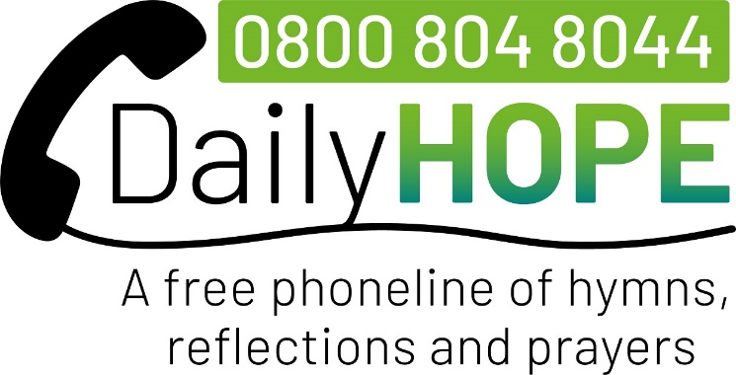

**Please let your Prayer Partners know if you find yourself struggling during the lockdown**, or Anne Elphick, Fr Andrew or the Churchwardens. We can help you - practically, pastorally, prayerfully and spiritually!

**NIFTY NOTES** due to the coronavirus these are not available as a booklet but can be downloaded from the Diocesan website.

**MENTAL HEALTH HELPLINE**

There is a new mental health helpline for adults and young people across Nottinghamshire. The Nottinghamshire Mental Health Helpline offers access to support for people who need emotional support or information about their mental health. The helpline number is 0300 555 0730 and is open from 9am until 11pm, 7 days a week. For more information and resources visit:

<https://www.turning-point.co.uk/nottingham-helpline>

For more info contact: Racheal Miller - [Nottinghamshire.Helpline@turning-point.co.uk](mailto:Nottinghamshire.Helpline@turning-point.co.uk)

**BULWELL CHURCHES TOGETHER MARKET STALL (TBC)**In place of the now annual event at the switching on of the lights on Bulwell Market, each fund-raising or promotional stall has been offered an opportunity to have a Market Stall. Dates for the stalls havn’t been allocated yet. Fr A is organising the stall for BCT so help on the day, with stall, would be appreciated. Please contact Fr A if you can help with this important Christian outreach.



**‘FAMILY 50’** Our Income for this period in this year is already £13,000 less than last year.  If the trend continues, we will only be able to make a Parish Share contribution of £12000 this year.  And, If the current covid-19 related restrictions continue much longer, we may even struggle to make that. We have suffered a loss of income because we have been unable to open up the Church building and function as normal.  However, it is obvious that we cannot continue to run the church at a deficit.  In order to make St Mary’s solvent, it is incumbent open us as the church congregation to either:

* Increase our financial giving
* Think of new ways to raise extra money
* Consider where substantial cuts or changes

can be made regarding how our church building is used, and our present forms of worship, mission and ministry.

The last option is probably the one folk would least like to consider!  So, with that in mind, I would like to launch **‘FAMILY 50’**. To help us meet our financial shortfall, I would like, please, to invite each church family or household to raise an extra £50 on top of their usual giving.  This could be done in a variety of covid-secure ways, and I’ll leave the means and method to the individuals concerned!  Some immediate ideas are:

* It may be that £50 is an amount you can afford

to give to St Mary’s as a gift

* You could undertake a sponsored

walk/shave/silence/Bible reading etc.

* You could collect loose change in jam jars.
* You could choose to give up something for

Advent, and gift the money you save to St Mary’s

* You could gift to St Mary’s what you might have

spent at our Fayres/Quiz Nights/Concerts etc

* Anything else you can think of - you are bound

to have much better ideas than me!

*****During the lockdown if you are unable to come to church and leave your weekly offering or Family 50 donation*, *or post a cheque, or pay online or by bank transfer, please speak with a Prayer Partner or the Churchwardens, Treasurer or Fr Andrew and we can arrange to pick it up for you.*